Professional practice online diary week 4

4.0 Introduction

This week we were tasked with creating a game where two players must work together in order to diffuse a bomb. The game must use a time limit where when the players exceed the time limit the bomb will blow up and the players will lose.

4.1 Materials

* Windows 7 or higher
* 2GB of RAM
* 1 GB of available storage

4.2 Game mechanics

Both players must work together in order to complete four puzzles before the timer runs out. The puzzles will be randomized at the beginning of each game so that the game does not become repetitive and boring. Once they have completed all of these tasks, they will then have to enter a password which will diffuse the bomb. The password will also be randomized, and the players will not be able to enter the password until all tasks have been completed to prevent the players skipping the task.

4.3 The game

At the beginning of the game the players will be shown the bomb they are going to have to diffuse. (figure 1)

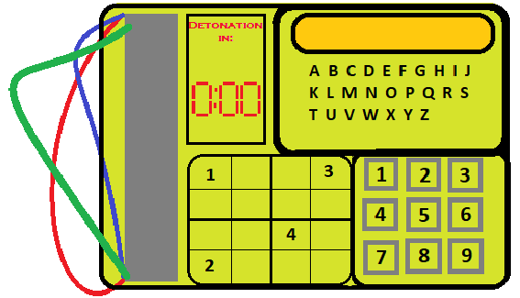

*(Figure 1. The bomb. Shows an example bomb the players will see at the beginning of the game)*

On the screen will be instructions on how to complete each of the tasks. The tasks on this bomb would be cut the wires in RGB order, Complete the sudoku puzzle. Enter all numbers between 1 and 50 that are prime numbers on the number pad and then join the red wire to the blue slot. While doing these tasks the players will be able to see the timer and each mistake, they make will lose them 3 seconds. At the end of each puzzle the player will receive a letter which they will then have to type try and figure out the password from the four letters they have received and type them into the keypad in order to finally diffuse the bomb. Failure to diffuse the bomb will cause the bomb to fail and you will lose. This game was inspired by keep talking and nobody explodes in the game the players must work together in order to complete multiple tasks to avoid the bomb exploding (figure 2)

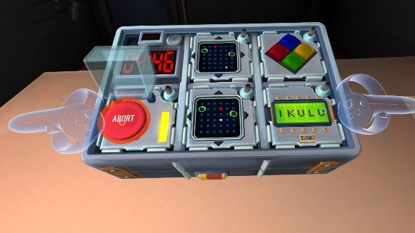

(*figure 2. The bomb puzzles. This shows the bomb in the game keep talking and nobody explodes*.)

4.4 Play testing

With restricted time we only had time for two players too play test our game. The first of which was Steve yap who enjoyed the idea of the game but was however concerned that the sudoku puzzle would take too long to complete. The other play tester was Muhammed Zulfiqar, who said that he liked the sudoku puzzle and the rest of the puzzles were very original for a bomb defusal game, so it was easy to pick up quickly.

4.5 Reflection

We found this task more challenging than others as there are not many bomb defusal games which caused us to spend much longer than twenty minutes researching ideas to put into our game. This caused us to have a much tighter time restraint on play testing which meant we could not implement any possible changes that we could have needed after the play testing. Next time I hope to be able to stick to the time restraints to prevent this from happening again.